**Chapter-2**

**Software Requirement Specification**

**2.1 Description of Food Ordering System (Block Diagram):**

Login/signup

process

Login

Sign-up

Order

Select

Order

your food

Manage food cart process

USER

.

Food

**Fig No-2.1: Block diagram for Food Ordering System**

**2.1.1 Product Features:**

The Food Ordering system is used by user, who wanted to get there food serve in there location in one click.

**2.1.1.1 Login/Sign-up**

This process is specifically for user. If He/She have account on the site ,then simply they have ro login . If they doesn’t have account then they have to sign-up and fill there details.

**2.1.1.2 Manage Food Cart Process**

In this process user will View and select the food of His/Her choice and add it to cart.

**2.1.1.3 Order Food**

In this the user can order the food which He/She added to cart.

**2.1.2 Input/ Output Data elements:**

|  |  |
| --- | --- |
| **Input/Output**  **Name** | **Data Elements** |
| Login | Email id, password |
| Manage food cart | Food quantity , Food name |
| Order Food | Delivery Status |

**2.1.3 Procedures/ rules/ mathematical relationships:**

Terms and condition

**2.2 Use Case Diagram**

A use case diagram is a dynamic or behaviour diagram in UML. Use case diagrams model the functionality of a system using actors and use cases. Use cases are a set of actions, services, and functions that the system needs to perform. In this context, a "system" is something being developed or operated, such as a web site. The "actors" are people or entities operating under defined roles within the system.

**Use Case Diagram of Food ordering syatem**

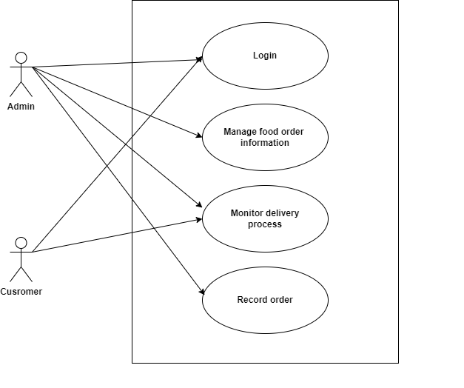

**Fig No-2.2: Use Case Diagram of Food ordering syatem**

**2.2.1 USE CASES**

**1. Login**

**1.1 Basic Flow**

1.This use case starts when the actor wishes to login to the Application.

2. The system requests that the actor enters his/her email Id and password.

**1.2 Alternate Flows**

**1.2.1 Invalid User Id /Password**

If in the Basic flow, the actor enters an invalid UserId and/or password, the system displays an alert message. The actor can choose to either return to the beginning of the basic flow or cancel the login, at that point, the use case ends.

**1.3.1 Sign-up**

1.This use case starts when the actor doesn’t have account on the site.

2. The system requests that the actor set’s his/her email Id and password for future login

**2. Manage Food cart process**

**2.1 Basic Flow**

The user will come and choose food of her choice and add it to cart.

**2.2 Alternative Flows**

None

**2.3 Software Product constraints:**

1. Limited to http/https.

2. No maintainability of backup.

**3. Order your food**

**3.1 Basic Flow**

After adding His/Her favourate food in the cart He/She can further proceed to order them at there door step.

**3.2 Alternative Flow**

None